WaterMe

Use-Case Specification: Enable Alarm

Version 1.0

Revision History

|  |  |  |  |
| --- | --- | --- | --- |
| **Date** | **Version** | **Description** | **Author** |
| 31/Jun/2017 | 1.0 | First Version | Paul Giesa |
|  |  |  |  |
|  |  |  |  |
|  |  |  |  |

Table of Contents

1. Use-Case Name 4

1.1 Brief Description 4

2. Flow of Events 4

2.1 Basic Flow 4

3. Espresso test 4

4. Preconditions 4

5. Postconditions 4

6. Function Points 5

Use-Case Specification: Enable Alarm

# Use-Case Name

## Brief Description

The user can decide whether the buzzer should make sounds when the humidity level is critical.

## Mockup

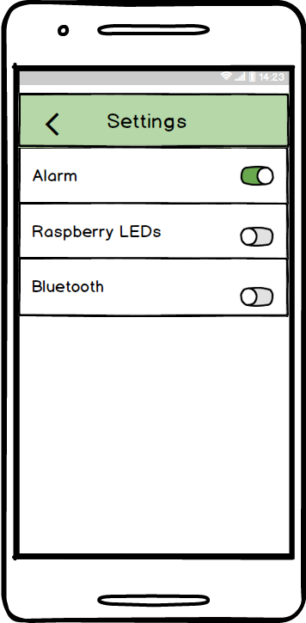

# Flow of Events

## Basic Flow

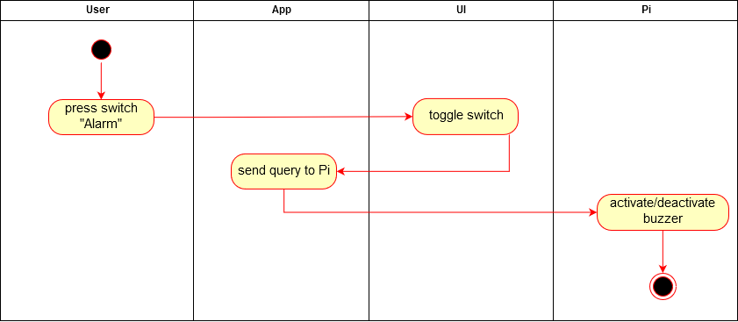

# Espresso test

# Preconditions

The app needs an active connection to the Pi. Also the user has to enter the “Settings Menu”.

# Postconditions

Either the alarm is activated or deactivated.

# Function Points

